**AZURE**

**Data centre in the past 🡺**

* **We have to buy and maintain infra for data centers earlier like this**

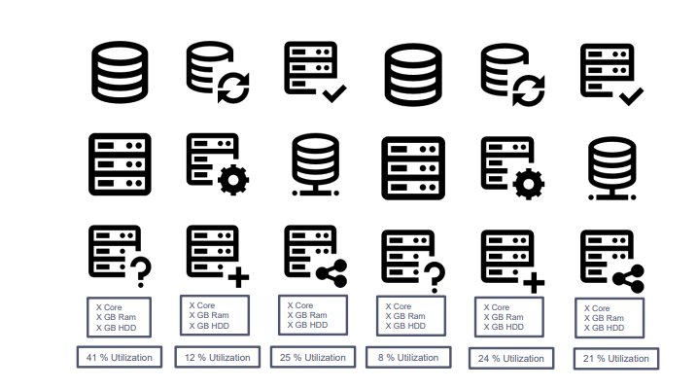

**Virtualization 🡺**

* **Instead of maintain multiple hardware sets, Virtualization came into picture where it creates virtual machines from one set of hardware by hypervisor.**

**Cloud computing 🡺**

* Cloud computing means Internet based Computing
* Renting IT Resources
* So, In simple terms, Cloud computing is on-demand resources delivered to you over the internet.
* Cloud Providers – Microsoft, AWS, Google
* Example – Gmail, Netflix, Dropbox
* Same resources shared by multiple clients

**Azure Portal 🡺**

* **Web-based, graphical user interface (GUI) for controlling Microsoft Azure**
* **Unified console that provides an alternative to command-line tools.**
* **Build, manage, and monitor everything from simple web apps to complex cloud deployments.**
* **Create custom dashboards for an organized view of resources.**
* **Azure Marketplace helps connect users with Microsoft partners, independent software vendors, and startups that are**
* **offering their solutions and services, which are optimized to run on Azure.**
* **Continuous availability**
* **Load from closest location**
* **Continuously maintained behind the scene and requires no downtime.**

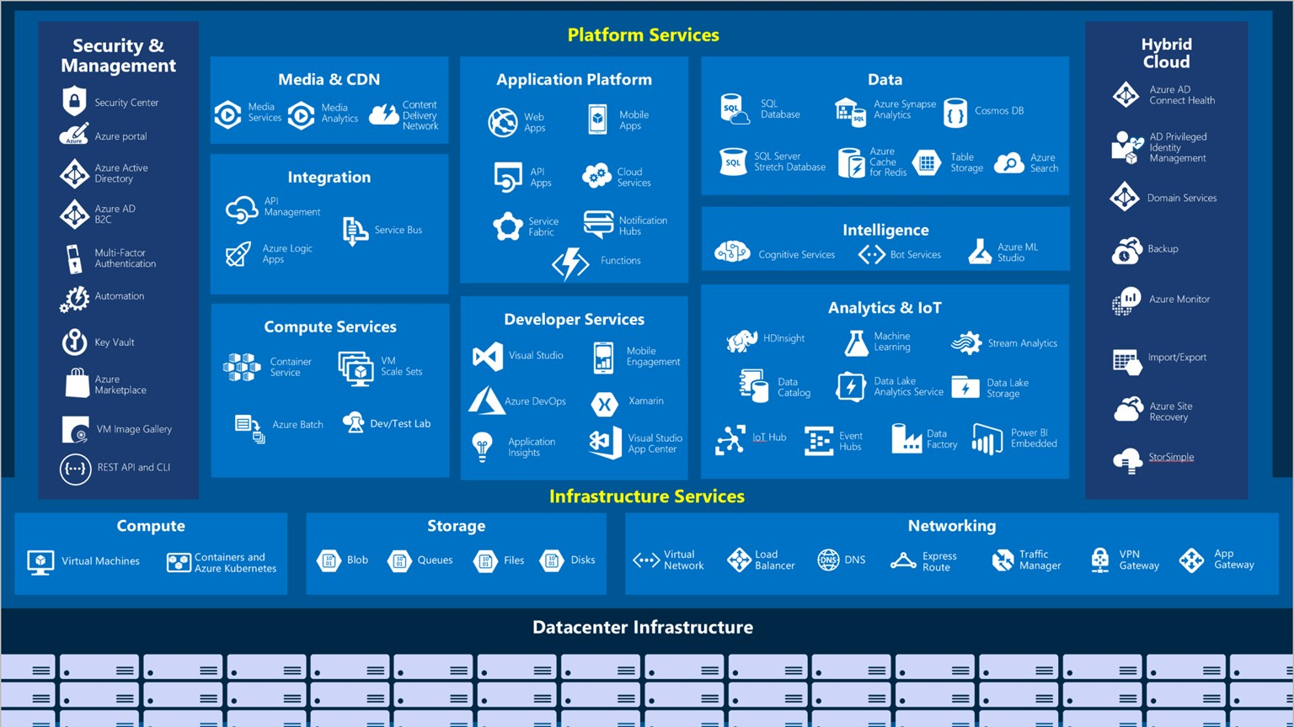

Set Budget and Delete Resources

* + FREE Subscription
  + Azure won't charge you for your free subscription.
  + Your FREE subscription and services are disabled once your credit runs out.
  + You must upgrade to continue using Azure services.
  + Paid subscription - VERY IMPORTANT
  + DELETE RESOURCES AFTER YOUR USE/DEMO
  + EVEN IF I DON’T TO TELL YOU AFTER DEMO

Set Alert - notify you when your spending reaches or exceeds the amount defined in the alert condition of the budget.

Cloud fundamental concepts

In this module, you will learn that how cloud computing will save your company time and money by migrating from your existing, on-premises, physical hardware, to a cloud solution.

You’ll also learn about the fundamental concepts of cloud computing, how Azure implements these concepts.

learning Objectives

* + High availability, Fault tolerance and Disaster recovery
  + Scalability, Elasticity, and Agility
  + CapEx vs OpEx
  + Economic benefits of the cloud
  + Consumption-based model
  + Computing Models
  + Categories of cloud services - SaaS vs PaaS vs IaaS
  + Deployment Models
  + Types of Cloud Computing - Public, Private and Hybrid
  + Cloud Pricing Model

## High availability, Fault tolerance and

**Disaster recovery**

### Common Goal: HA, FT, DR

* Goal: User continue to access application, even when things go wrong.
* Common reasons for loss of availability
  + Network outage
  + Application failure
  + System outage
  + Power outage
  + Catastrophic disaster (Earthquakes, tsunamis, flood, tornado, etc.)

**Disaster Recovery**

**High Availability and Fault Tolerance**

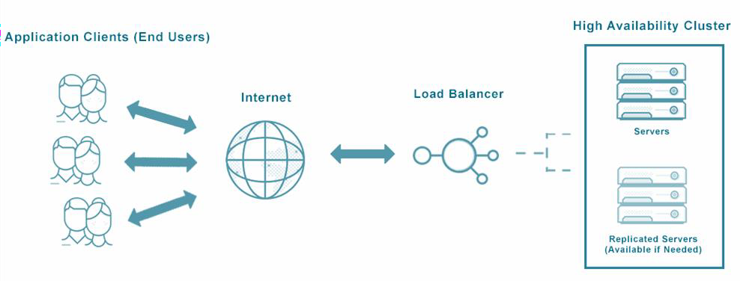

Protect against data center, server, network and storage subsystem failures to keep your business running without downtime.

Highly available systems are reliable in the sense that they continue operating even when critical components fail.

They are also resilient, meaning that they can simply handle failure without service disruption or data loss, and seamlessly recover from such failure.

Azure provide high availability features such as redundancy, load balancing, auto-scaling and provisioning across Availability Zones (AZ), representing isolated parts of an Azure data center.

High Availability

**Service Level Agreement (SLA)** guarantees a certain level of availability as a percentage

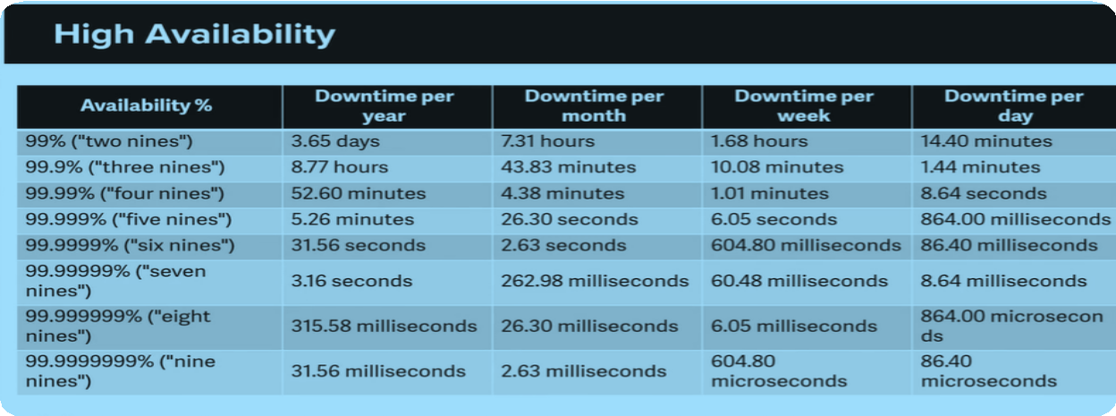

**Scalability, Elasticity, and Agility**

Benefits of using the cloud

Scalability

Resources cost money

* Charged for diskspace, CPU, memory, bandwidth
* Minimize cost by minimizing resources used

Resource needs change quickly

* Resource demand can fluctuate based on
  + Particular day
  + Time of day
  + Increase in popularity

**Scalable** architectures provide the ability to grow your environment when this is needed (increase in number of users, traffic throughput)

* Example: Workload increased as business expanded over a period of time
* Two types of Scalability:
  + Vertical Scalability
  + Horizontal Scalability

* Increasing a capacity of current server: A larger hard drive, A faster CPU, More RAM, CPU, I/O, or networking capabilities
* Has Limits

* Deploying multiple instances of application/database
* Increases availability
* Horizontal Scaling needs additional infrastructure: Load Balancers, auto scaling group etc.

Scalability vs Elasticity

* **Scalable** architectures provide the ability to grow your environment when this is needed (increase in number of users, traffic throughput)
* Example: Workload increased as business expanded over a period of time
* Two types of Scalability:
  + - Vertical Scalability
    - Horizontal Scalability
* **Elasticity**: Ability to automatically expand or compressed the infrastructural resources on a sudden-up and down in the requirement so that the workload can be managed efficiently.
* Example: workload increases during festive season like Christmas.

|  |  |
| --- | --- |
| Elasticity | Scalability |
| ⮚Elasticity is used just to meet the sudden up and down in the workload for a small period of time.  ⮚Elasticity is used to meet dynamic changes, where the resources need can increase or decrease.  ⮚It is a short term planning and adopted just to deal with an unexpected increase in demand or seasonal demands. | ⮚Scalability is used to meet the static increase in the workload.  ⮚Scalability is always used to address the increase in workload in an organization.  ⮚Scalability is a long term planning and adopted just to deal with an expected increase in demand |

Agility

**Agility**: Rapidly deploy and configure cloud resources as your app's needs change.

* Speed and flexibility of scaling in the cloud

**CapEx vs OpEx**

Capital Expenditure (CapEx) vs Operational Expenditure (OpEx)

CapEx vs OpEx

Capital Expenditure (CapEx)

* Upfront cost
* Spending money ahead on physical infrastructure and then deducting that cost over time from your tax bill.
* Example: Deploying your own data center
* Server, Storage , Network , Backup and archive , Disaster recovery, Datacenter infrastructure
* Summary: CapEx requires significant up-front financial costs, as well as ongoing maintenance and support expenditures.

Operational Expenditure (OpEx)

* Pay-as-you-go pricing
* There is no up-front cost, as you pay for a service or product as you use it.
* Pros: Demand and growth may be unexpected and exceed estimates, posing a capex issue.
* Example: Cloud Services
* Summary: OpEx is a consumption-based model, so company is only responsible for the cost of the computing resources that it uses.

**Benefits of the cloud computing**

New Startup

Traditional Data Center Challenges

Cloud Computing Benefits

Traditional Data Center Challenges

* Large up-front investment
* Forecast Infrastructure needs
* Took 5 months to setup there server
* Suddenly become popular
  + lot of users, experiencing latency
  + Scaling will need further few months of effort
  + Security and Compliance burden
* Less Load during off season
  + Now, difficult to scale down
  + Maintenance cost still going on
* Plan to Expand Globally
* Same challenges again

Advantages of Cloud Computing

* Trade capital expense for variable expense
  + No Initial investment
  + Pay only for how much you use – do not own hardware
* Stop guessing capacity
  + You can access as much or as little capacity as you need, and scale up or down in minutes.
* Increase speed and agility
  + New IT resources are only a click away
  + Reduce resource deployment time from weeks to minutes.
* Benefit from massive economies of scale
  + AWS can aggregate usage from hundreds of thousands of customers, they can lower pay-per-use prices.
* Stop spending money running and maintaining data centers
* Go global in minutes: In just a few clicks, you can easily deploy your application to multiple regions worldwide.

**Consumption-based model**

pay-as-you-go model

### Consumption-based model vs fixed cost model

* Cloud pricing model in which clients are only pay for the resources they utilize.
* There are no upfront fees.
* No need to buy and maintain expensive infrastructure
* Pay just for what you need.
* When you don’t need, don’t have to pay

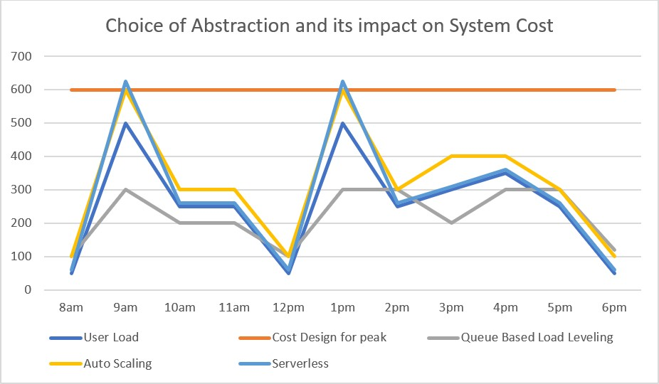

**Computing Models**

Categories of cloud services - SaaS vs PaaS vs IaaS

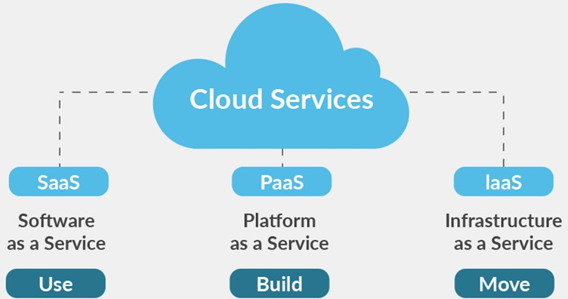**SaaS vs PaaS vs LaaS**

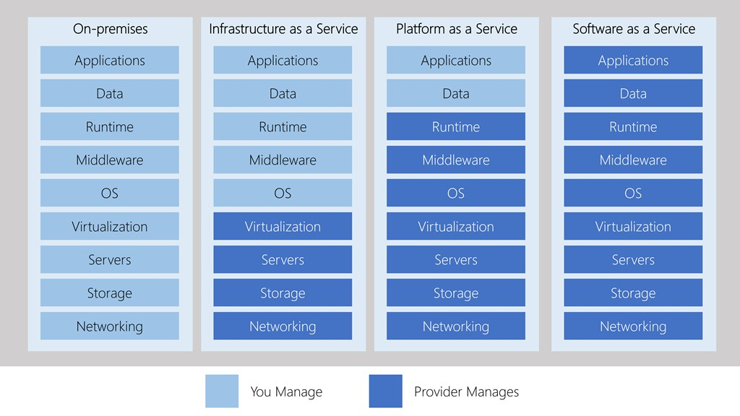

## Shared responsibility Model

Who owns the workload responsibility?

### Shared responsibility in the cloud

*Workload responsibilities vary depending on whether the workload is hosted on SaaS, PaaS, IaaS or on-premises datacenter*

**Deployment Models**

Types of Cloud Computing - Public, Private and Hybrid

Cloud Deployment Models

|  |  |  |
| --- | --- | --- |
| Public Cloud | Private Cloud | Hybrid Cloud |
| * Cloud resources are those that are owned and managed by a third-party cloud service provider and are provided through the Internet. * Advantages * No Maintenance * Near unlimited scalability * High reliability * Disadvantages   + Less control * Use case scenario   + Deploy website quickly   + Focus on development | * Cloud services that are utilized by a particular organization and are not accessible to the general public. * Advantages * No Legal obligation * Control * Strict security and compliance * Disadvantages * Infrastructure cost * Difficult to elasticity * IT Skills * Use case scenario * Government policy requires specific data to be kept in- country | Combination of public and private cloud with automation and orchestration between the two  **Advantages**: Use your own equipment to meet security, compliance, or legacy scenarios  Disadvantages   * Expensive * Complicated   Use case scenario   * Medical data can’t expose to * public. * Application runs on old hardware. |

**Cloud Pricing Models**

Traditional Data Center Cost

* Upfront Hardware cost
* Building, electricity, cooling, Internet
* Employees to maintain infrastructure
* Software/Application licenses
* And so on…

Cloud Computing Cost

Can we save money?

* + Yes, but It’s not straight forward
* Bill could depends on multiple metrics for each service
* Example: “Storage Service” pricing depends on:
  + Volume of data stored per month.
  + Quantity and types of operations performed
  + Data transfer costs.
  + Data redundancy/backups
* Example “VM” Pricing depends on:
  + Overall CPU time
  + Time spent with a public IP address
  + Incoming (ingress) and outgoing (egress) network traffic in and out of the VM
  + Disk size and amount of disk read and disk write operations

###### Always FREE

* Always FREE
* Virtual Network
* Azure Policy
* Azure Active Directory
* Azure Migrate
* Azure Open Datasets
* Azure Lighthouse
* Azure Private Link
* Azure Data Catalog
* Azure Service Fabric

###### Pay: Time

* Charge based on time you use a particular service
* Other imp parameters like performance tiers and other configurations
* Examples:
* Virtual Machine
* App Services
* SQL Database
* Load Balancer

###### Pay: GB

* Database Storage
* Storage Service
* Network traffic (between regions)

###### Pay: Operations

* Charges based on number of operation
* Example: Cost per million operation
* Storage services (read, write or delete operations)
* Cosmos DB

###### Pay: Execution

* Serverless offerings
* Charges only when you use, per execution
* Azure Function
* Serverless Database
* Logic Apps

###### Pay: Other metrics

* Example: Azure Active Directory Premium tier
* Charge based on number of user licenses
* Regions/Locations
* How you purchase service

###### Other Parameters

* Through an Enterprise Agreement
* Directly from the web
* Through a Cloud Solution Provider
* Support options
* Programs and offers
* And so on….

### Benefits of Cloud Computing

**High availability:** Provide a continuous user experience with no apparent downtime

**Scalability**: Apps in the cloud can scale vertically and horizontally:

* **Vertically** expand a virtual machine's computing capability by adding RAM or CPUs.
* **Horizontal** scaling improves computing capacity by increasing instances of resources, such as VMs.

**Elasticity**: Cloud-based applications may be configured to use autoscaling, ensuring they always have enough resources.

**Agility**: Rapidly deploy and configure cloud resources as your app's needs change.

**Geo-distribution:** Global geo-distribution of applications and data ensures that consumers get the optimum performance in their area.

**Disaster recovery:** Cloud-based backup services, data replication, and geo-distribution allow you to deploy applications with assurance that your data will be secure in the event of a disaster.

# Azure Global Infrastructure

Data Centers, Regions, Region pairs

Regions

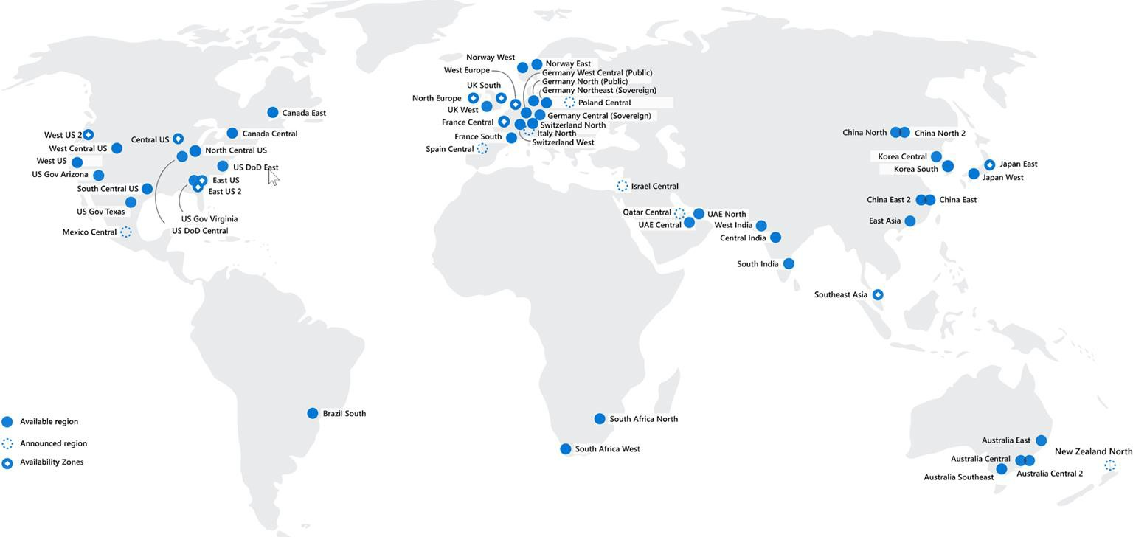

* Region, which is a physical location around the world where we cluster data centers.
* Azure has more global regions than any other cloud provider.
* Better scalability and redundancy
* Preserve data residency
* Low Latency
* Global Footprint
* High Availability
* How to choose region?
* Compliance
* Proximity
* Available services
* Pricing

Azure region pairs

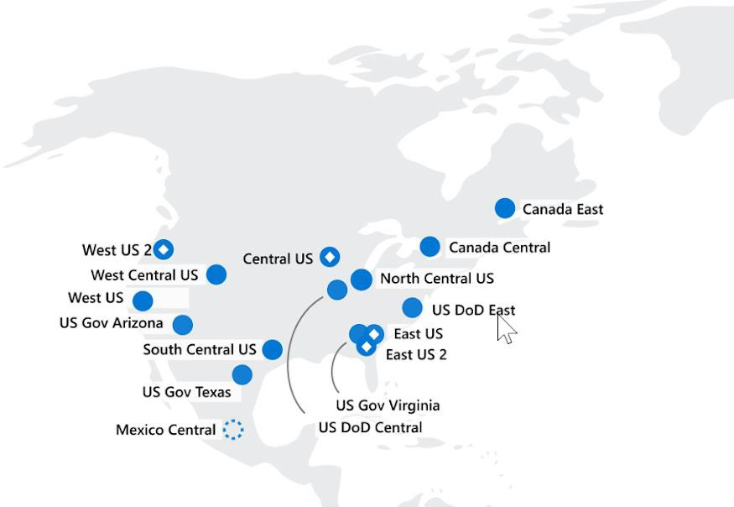

* Each Azure region is always paired with another region within the same geography
* Data centers are usually 300+ miles apart
* Automatic replication and failover for some azure services.
* Additional advantages of region pairs:
* If an extensive Azure outage occurs, one region out of every pair is prioritized to make sure at least one is restored as quickly as possible for applications hosted in that region pair.
* Planned Azure updates are rolled out to paired regions one region at a time to minimize downtime and risk of application outage.
* Data continues to reside within the same geography as its pair.

# Azure Global Infrastructure

Availability Zones

Regions



**Availability Zones**

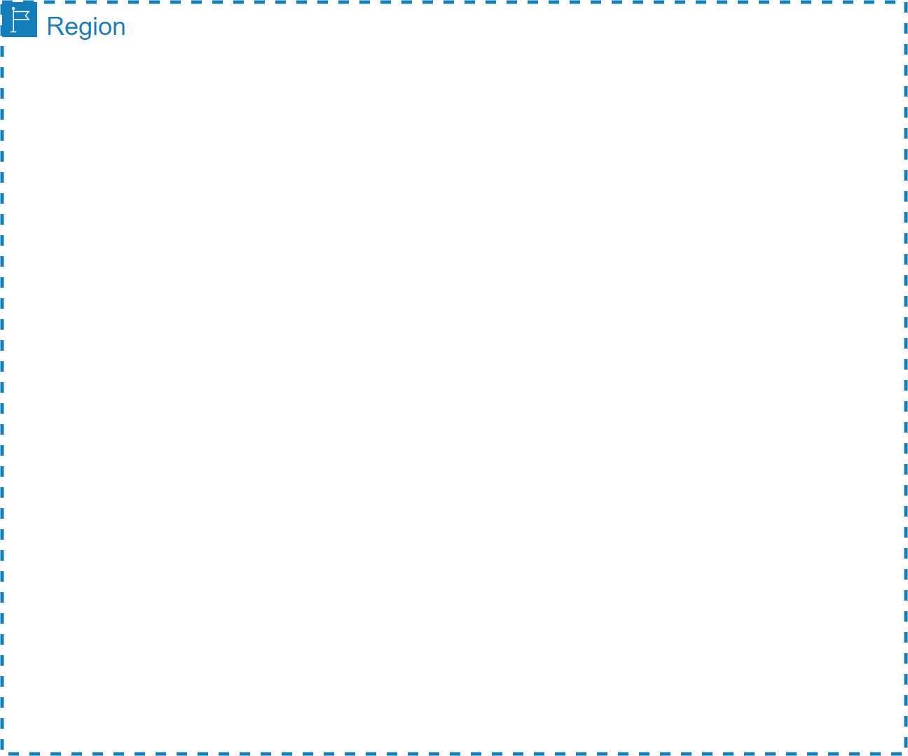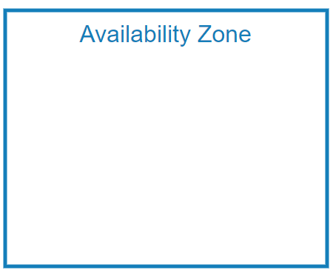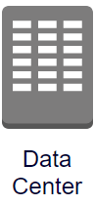

High-speed, private

fiber-optic networks

* Region represents a separate geographic area.
* Availability zone is a set of discrete data centers.
* Availability zone is set up to be an isolation boundary. If one zone goes down, the other continues working.
* Each availability zone has independent power, cooling and networking.
* Availability zones are connected via high bandwidth, ultra-low latency networking
* AZs are physically separated by several kilometers, while being within 100 km (60 miles) of one each.
* All AZ traffic is encrypted.
* Not every region has support for availability zones.

**Resource Groups**

Logical container for resources

### Organizing structure for resources

* Resources: Resources are instances of services that you create, like virtual machines, storage, or SQL databases.
* Resource groups: Resources are combined into resource groups, which act as a logical container into which Azure resources like web apps, databases, and storage accounts are deployed and managed.
* Subscriptions: A subscription groups together user accounts and the resources that have been created by those user accounts. For each subscription, there are limits or quotas on the amount of resources that you can create and use. Organizations can use subscriptions to manage costs and the resources that are created by users, teams, or projects.
* Management groups: These groups help you manage access, policy, and compliance for multiple subscriptions. All subscriptions in a management group automatically inherit the conditions applied to the management group.

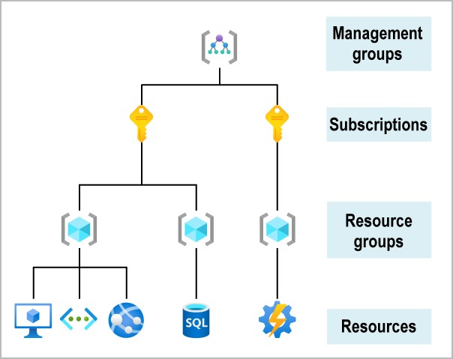

### Resource Groups

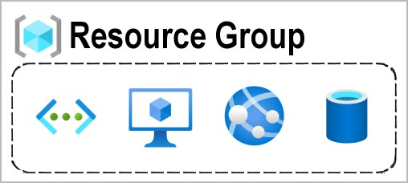

* Resources: are anything you create in an Azure subscription like VMs, Azure Application Gateway instances, and Azure Cosmos DBinstances.
* Resource group is a logical container which help manage and organize your Azure resources.
* For example similar usage, type, or location
* Each resource can exist in only one resource group.
* You can move a resource from one resource group to another group.
* Resource groups can't be nested.
* The resources in a resource group can be located in different regions than the resource group.
* Resource group created at location – to store metadata.
* A resource group can be used to scope access control for administrative actions. To manage a resource group, you can assign Azure Policies, Azure roles, or resource locks.
* You can apply locks to a resource group or subscription to prevent deletion or make contained resources read-only. You can also apply locks directly to a resource.
* You can apply tags to a resource group. The resources in the resource group don't inherit those tags.
* Life cycle: When you delete a resource group, all resources in the resource group are also deleted.
* To create a resource group, you can use the portal, PowerShell, Azure CLI, or an ARM template.

# Azure Resource Manager

Deployment and management service for Azure

### Azure Resource Manager (ARM)

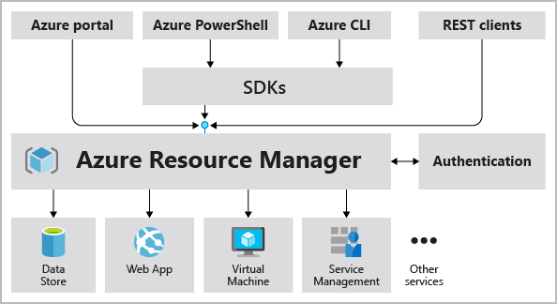

* Atomate resource deployments (create, update, and delete) using templates.
* ARM template is a JSON file that defines what you want to deploy to Azure.
* Integrates with Azure portal, PowerShell, CLI, and REST API to perform deployment and management tasks.
* Easy way to deploy multiple resource instances or reliably redeploy resources.
* ARM template can be used to deploy the resources consistently and repeatedly.
* Define the dependencies between resources so they're deployed in the correct order.

# Subscription

How you are billed for resource usage

**Subscriptions**

* Using Azure requires an Azure subscription.
* An Azure subscription is a logical unit of Azure services that links to an Azure account. It also allows you to provision resources.
* A subscription provides you with authenticated and authorized access to Azure products and services.
* Azure generates separate billing reports and invoices for each subscription
* Two types of subscription boundaries
  + Billing boundary
  + Access control boundary
* You can create separate subscription based on:
  + Environment: development and testing, security, or to isolate data for compliance reasons
  + Organizational structures: IT, HR, Admin and so on
  + Billing: manage and track costs based on your needs, for example – Production, Test and Dev
* Different types of Subscription:
  + FREE: An email address and a credit card are required to sign up for a free trial subscription that provides $200 credit for the first 30 days and 12 months of restricted access.
  + Pay-Per-Use: Charges monthly based on Cloud resource use.
  + Enterprise: A single Enterprise agreement is established for large subscription purchases, including savings for new licenses and Software Assurance.
  + Student: This membership includes $100 for 12 months and may be activated without a credit card.

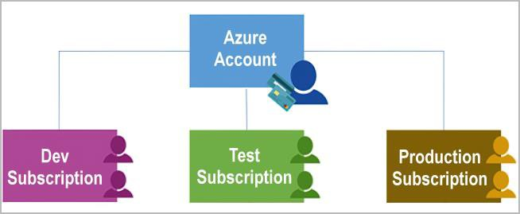

# Management Groups

Organize multiple subscriptions as a single management entity

### Management groups

* Management groups let you organize multiple subscriptions as a single management entity to facilitate easier management.
* You can create managements groups in a hierarchical structure with the top level of the hierarchy at the tenant level and containing all subscriptions in that tenant.
* Any conditions applied to a management group apply to all subscriptions contained in that management group object.
* Each management group and subscription can support only one parent.
* Each management group can have many children.
* The root management group can't be moved or deleted, unlike other management groups.

# Azure Sovereign Regions

Azure Sovereign Regions

* Different from Public Cloud
* Specific regions of azure that were created to meet high security and other regulatory and compliance requirements for specific markets
  + Azure Government (Only for US government)
  + Azure China

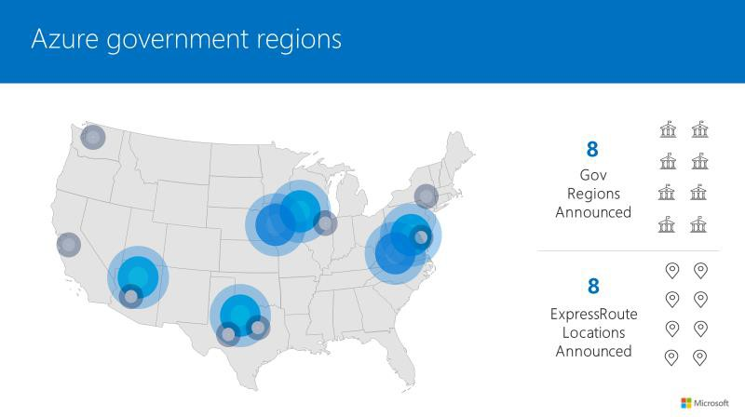Azure Government

* Specially Designed for US government
* Azure Government is operated directly by Microsoft.
* Separate Instance (https://portal.azure.us)
* Portal experience is same
* Physically Isolated Datacenters
* Authorized personal only can access services and infrastructure
* Azure Government customers that are eligible to use Azure
* Government cloud are:
* US federal state
* State or local government agencies or their partners
* Azure Government is not available for public use.

Azure China

* Azure China is designed for organizations doing business in China that need to meet Chinese regulations.
* Microsoft is not physically running services in China
  + - Azure China is controlled by a Chinese data trustee (21Vianet).
* Azure China is a physically isolated
* Separate instance (https://portal.azure.cn)
* Text, chat or text message

  Description automatically generatedAll data and related systems physically reside in China.

Data Centers, Regions, Region pairs

Regions - physical location around the world where we cluster data centers.

Availability Zones 🡺

* Availability zone is a set of discrete data centers
* Each availability zone has independent power, cooling and networking.

Resource Groups 🡺

Resource group is a logical container which help manage and organize your Azure resources.

Azure Resource Manager (ARM) 🡺

ARM template is a JSON file that defines what you want to deploy to Azure.

Subscription 🡺

Azure subscription is a logical unit of Azure services that links to an Azure account

Management Groups 🡺

Organize multiple subscriptions as a single management entity to facilitate easier management.

#### Azure Compute Services

#### Azure Compute Services

COMPUTE 🡺

Compute Services

❖ Azure Container Instances

❖ Azure Kubernetes Service

❖ Azure Functions

❖ Azure Virtual Desktop

❖ Azure Virtual Machines

❖ Azure App Service

Azure Virtual Machine

⮚ With Azure Virtual Machine service, you can create and use VMs in the cloud.

⮚ Infrastructure-as-a-Service (IaaS)

⮚ Full control over machine just like your physical computer

⮚ Operating System (OS): Linux or Windows

⮚ Size of VM – CPU, RAM, disk/storage and so on

⮚ Network configurations: Virtual network, Subsets

⮚ Firewall rules: security group

⮚ The ability to run custom software.

⮚ To use custom hosting configurations.

⮚ Must maintain and patch VM

⮚ Need to configure, update, and maintain the software that runs on the VM.

Azure Virtual Machine

Imp options to choose while creating VM:

⮚ Type of image – OS and software

⮚ Size of VM – CPU/RAM/Storage

⮚ Availability options

Use Cases:

⮚ During testing and development.

⮚ Application might need to handle fluctuations in demand

⮚ shutting down VMs when you don't need them

⮚ During disaster recovery.

⮚ Move to the cloud with VMs

Load Balancer

Deliver high availability and network performance to your apps

Load Balancer

▪ Distribute traffic to your backend virtual machines

▪ Provides high availability for your application.

▪ Two types of load balancer: Public and Private

▪ Components:

▪ Frontend IP: define IP address for the load balancer

▪ Backend pool: this contains the virtual machines

▪ Health probes: monitor health of resources in backend pool

▪ Rules: How to distribute the incoming traffic.

between different VMs.

Availability Zones

▪ Each Availability Zone has a distinct power source, network, and cooling.

▪ If one zone is compromised, then replicated apps and data are instantly available in another zone.

▪ It’s your responsibility to sync applications between different VMs.

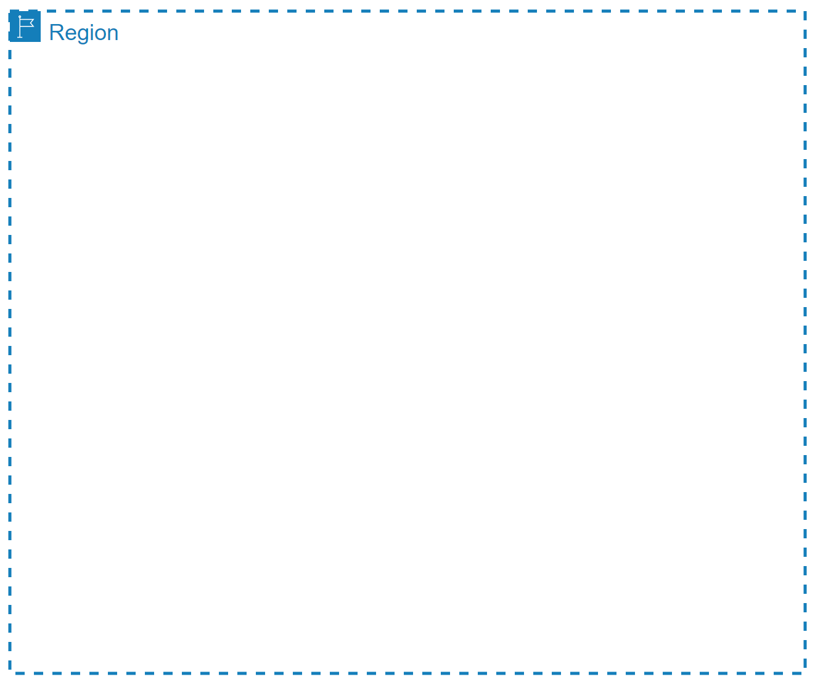

High-speed, private

fiber-optic networks

Availability Sets 🡺

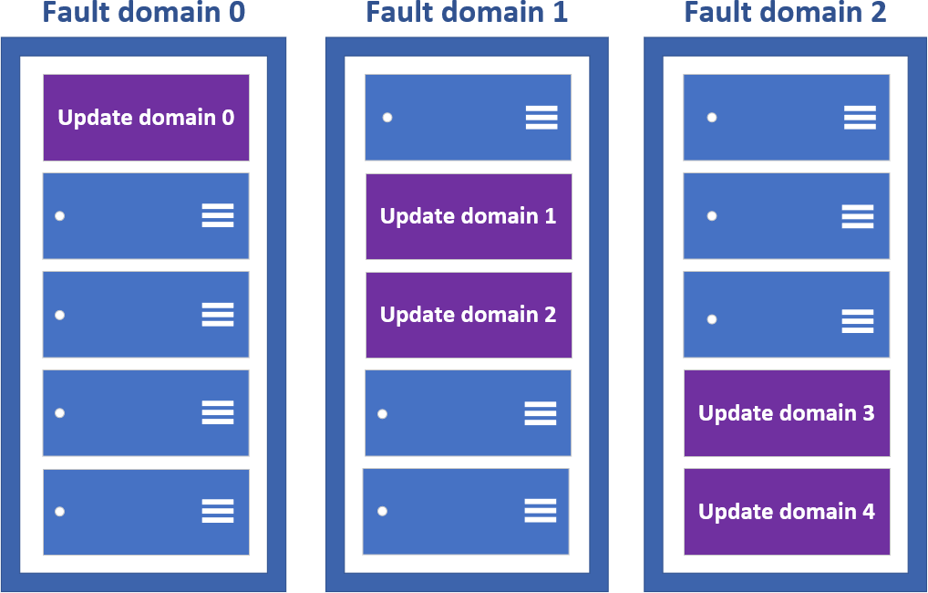

▪ Availability Sets make use of two key concepts - Fault Domains, and Update Domains.

▪ Update domains define the group of virtual machines that are going to be

patched/maintained/rebooted at same time.

▪ Fault domains define the group of virtual machines that share a common power source and network switch.

▪ It saves from rackwide failure, or a rackwide maintenance window that can take down all VMs hosted on this single point of failure.

▪ Availability sets are free to use! You only pay for the virtual machines being created.

▪ It does not protect your application from operating system or application- specific failures, it does limit the impact of potential physical hardware failures, network outages, or power interruptions.

Virtual Machines Scale Sets

▪ Create and manage a group of load balanced VMs.

▪ Allows your application to automatically scale as resource demand changes

▪ The number of VM instances can automatically increase or decrease in response to demand or a defined schedule.

▪ All VM instances are created from the same base OS image and configuration.

▪ VM size, disk configuration, and application installs should match across all VMs.

▪ Provides high availability and application resiliency

▪ Can use availability zones or availability sets

▪ There is no cost for the scale set itself, you only pay for each VM instance that you create.

Azure App Service

⮚ Enables you to host and manage your web applications

⮚ Platform as a service (PaaS) environment

⮚ Focus on the business value and logic

⮚ Azure handles the infrastructure

⮚ Automatic scaling and high availability

⮚ Programming language of your choice

⮚ Supports Windows and Linux

⮚ Automated deployments from GitHub or Azure DevOps

⮚ Pay only for compute resources your app uses

⮚ App Service plan determines how much hardware is devoted to

your application

Types of app services

Web apps

⮚ Full support for hosting websites and web applications

⮚ Language: ASP.NET, ASP.NET Core, Java, Ruby, Node.js, PHP, or Python.

⮚ Operating System: Windows or Linux

⮚ Web apps for containers can host your existing container images.

API apps

⮚ Build REST-based web APIs

⮚ Choice of language and framework

⮚ Can be consumed from any HTTP- or HTTPS-based client.

WebJobs

⮚ Run a program (.exe, Java, PHP, Python, or Node.js)

⮚ Run a script (.cmd, .bat, PowerShell, or Bash)

⮚ Can be scheduled or run by a trigger

⮚ Often used to run background tasks as part of your application logic.

Mobile apps

⮚ Quickly build a back end for iOS and Android apps

⮚ Store mobile app data in a cloud-based SQL database.

⮚ Authenticate customers against common social providers, such as MSA, Google, Twitter, and Facebook.

⮚ Send push notifications.

⮚ Execute custom back-end logic in C# or Node.js.

Containers

⮚ Problem Statement 1: I can’t share project with others because of dependencies on OS, framework, libraries and so on.

⮚ Problem Statement 2: Need different machines to run three different Python-based applications that use of a different version of Python

⮚ Solution: The simple solution is to create a container of your project in which you mention all the dependencies to run the project.

Thus your project can be run universally on any computer having container runtime installed.

⮚ Containers are a way to wrap up an application into its own isolated package.

⮚ In a nut shell, Container is the modern era solution for transferring your projects to friends, family, colleagues, clients etc without worrying about their system configuration to run the project.

Imp Features:

⮚ Portability: Deploy to diff environment

⮚ Consistency: will behave same each time

⮚ No maintenance related to infrastructure

⮚ Deployment and maintenance are efficient

⮚ Auto scaling

ACI vs AKS

⮚ ACI is a service that lets you deploy containers on Azure without having to

maintain or patch the environment.

⮚ Basic web applications, DevTest scenarios, and batch processing are all supported by ACI.

⮚ When you just need to run a few containers, it's a perfect option.

⮚ Limited scalability and low availability

⮚ Managed environment

⮚ Only pay for containers

⮚ Deployment is easy.

⮚ Alternatively, For more complex container designs where you require additional control over the health and performance of your containers, you may utilize Azure Kubernetes Service (AKS).

⮚ You can coordinate the deployment, update, and management operations for all of your containers using AKS.

⮚ If you need to operate tens, hundreds, or even thousands of containers, the AKS Open source project could be a good fit.

⮚ It's one tool in a class of tools called container orchestrators

Azure Kubernetes Services (AKS)

⮚ Azure's container management system

⮚ Scale your application to meet demands by adding and removing container instances

⮚ Monitor the deployed containers and resolving any issues that may come

⮚ Groups of containers are called Pods

⮚ Virtual machines are called Nodes

⮚ Azure Container Registry pull

Virtual Machine vs Containers

⮚ Virtual machine contains a full copy of an operating system

⮚ Virtual machine virtualizes the underlying hardware, meaning the CPU, memory, and storage

⮚ Containers, on the other hand, virtualize the operating system.

⮚ Containers smaller in size than a virtual machine and quicker to spin up because you're only waiting for the app to launch, not the operating system.

Docker & Azure Container Registry

Azure Container Registry

⮚ An image is a read-only template with instructions on how to create the container.

⮚ Container is the runnable instance of the image.

⮚ A container registry is a service that stores and distributes container images.

⮚ Docker Hub is a public container registry on the web that serves as a general catalog of images.

⮚ Azure offers a similar service called Azure Container Registry, which gives customers complete control over their images, integrated authentication with Azure AD, and more.

Container Registry

What is Docker?

⮚ A Docker container is a standard that describes the format of containers and provides a runtime for Docker containers.

⮚ Docker is an open source project that automates the deployment of containers that can run in the cloud or on-premises.

⮚ Docker is also a company that promotes and evolves the technology, and they work in collaboration with cloud vendors like Microsoft.

⮚ The result from adopting docker, or container, is that application can be deployed or undeployed faster, start and stop faster, change to

another “image” faster, process and do many things faster.

⮚ Apps run the same, regardless of where they’re run

⮚ Any machine

⮚ No compatibility issues

⮚ Predictable behavior

⮚ Works with any language, any OS, any technology

Azure Virtual Desktop

Some challenges

⮚ IT management overhead

⮚ Security management

Solution

⮚ Separates local hardware from your operating systems, data and apps from

⮚ Separate the compute environment from user devices so that the risk of confidential information being left on a personal device is greatly reduced.

⮚ Connect with any device over the internet

Provide:

⮚ Full desktops to users or

⮚ Direct access to an app running on a virtual machine.

⮚ Enables your users to use a cloud-hosted version of Windows from any location.

⮚ Fully managed solution in the cloud

Connect from any device:

⮚ Windows

⮚ Mac

⮚ iOS

⮚ Android

⮚ HTML5 Browser

⮚ Similar to Remote Desktop Services (RDS)

Key features of Azure Virtual Desktop

⮚ Supports Windows 10 multi-session

⮚ Host pools can allocate users to sets of VMs,

⮚ Configure size of VM and number of Users

⮚ Breadth mode – Best performance, allocate sequentially

⮚ Depth mode – save cost, fully allocated on one VM before moving to the next

⮚ Automatically add VMs when demand reaches a threshold.

⮚ Scale the VMs up and down

⮚ Use Azure Marketplace prebuilt VM images or provide your own custom images.

⮚ Unique and secure experience for user

⮚ Feels like they're working on their local computer.

⮚ Supported operating systems:

⮚ Windows Server 2019

⮚ Windows Server 2016

⮚ Windows Server 2012 R2

⮚ Windows 10 Enterprise

⮚ Windows 7 Enterprise

⮚ Save cost

⮚ Bring your own licenses

⮚ Buy reserved instance

Why should you use Azure Virtual Desktop?

⮚ Low Latency

⮚ Run host virtual machines (VMs) near apps and services that connect to your datacenter

⮚ Fast user sign-in

⮚ user profiles are containerized by using FSLogix.

⮚ Secure

⮚ Authentication using Azure AD

⮚ Azure Multi-factor Authentication

⮚ Role-based access controls (RBACs) to users

⮚ No confidential data on personal device.

⮚ User sessions are isolated in both single and multi-session environments.

Azure Serverless Technologies

Serverless computing

⮚ Serverless computing is the idea that servers, infrastructure, or operating systems are behind the scene and for users they do not exist.

⮚ Infrastructure isn't your responsibility.

⮚ Scaling and performance are automatically taken care of.

⮚ Azure takes care of the servers and how resources are allocated and deallocated.

⮚ Micro-billing: Pay only for the time their code runs.

⮚ For example, if the code runs once a day for two minutes, they're charged for one execution and two minutes of computing time.

⮚ There isn't even a need to reserve capacity.

⮚ Event-driven: Excellent fit for workloads that respond to incoming events. Events include triggers by:

⮚ Timers, for example, if a function needs to run every day at 10:00 AM UTC.

⮚ HTTP, for example, API and webhook scenarios.

⮚ Queues, for example, with order processing.

⮚ And much more.

⮚ Azure has two implementations of serverless compute:

⮚ Azure Functions: Functions can execute code in almost any modern language.

⮚ Azure Logic Apps: Logic apps are designed in a web-based designer and can execute logic triggered by Azure services without writing any code.

Azure Function

Azure Functions provide a serverless compute experience.

Azure Functions

⮚ It is a serverless platform

⮚ Execute your code when needed

⮚ Event-driven solution - execution of your code is triggered by a specific type of event.

⮚ Pay only for the time spent running your code.

⮚ No worry about configuration or management of the underlying physical and application infrastructure.

⮚ Azure Functions can be triggered by various event types, including HTTP requests.

⮚ Functions scale automatically based on demand

⮚ Functions can be either stateless or stateful.

⮚ Resilience: If one of your functions fails, it has no effect on other functions.

⮚ User Case:

⮚ Process file uploads - Run code when a file is uploaded or changed in blob storage

⮚ Build a web API - Implement an endpoint for your web applications using the HTTP trigger

⮚ Respond to database changes - Run custom logic when a document is created or updated in Cosmos DB

Logic Apps

Quickly build powerful integration solutions

⮚ Designed to automate business scenarios

⮚ logic apps execute workflows

⮚ Workflow includes actions like data conversions and flow controls, such as conditional statements, switch statements, loops,

and branching.

⮚ Design using visual designer on the Azure portal or in Visual Studio

⮚ Built from predefined logic blocks.

⮚ More than 200 different connectors and processing blocks to interact with different services.

⮚ Starts with a trigger

What is Serverless technology

Serverless computing is the idea that servers, infrastructure, or operating systems are behind the scene and for users they do not exist.

Infrastructure isn't your responsibility

Advantages of Serverless technology

Scaling and performance are automatically taken care of

Micro-billing: Pay only for the time their code runs.

There isn't even a need to reserve capacity.

Event-driven

Azure Functions

Execute your code when needed

Azure Logic Apps

Designed to automate business scenarios

#### Azure networking services

* In this module, you'll learn about the different Azure networking options and the scenarios in which each is appropriate.

Need for Azure Virtual Network

⮚ In a corporate on-premises data center network:

⮚ Nobody on the internet see the data exchange between the application and the database?

⮚ Nobody on the internet can directly connect to your

database

⮚ You must first establish a connection to your corporate network before gaining access to your apps or databases.

⮚ Corporate networks offer a secure internal network that safeguards your resources, data, and communications from unauthorized access.

⮚ How can you build your own private cloud network?

⮚ Azure Virtual Network

Azure Virtual Network

⮚ Your own isolated network in Azure.

⮚ Region can have multiple VNets but each VNet belong to same Region

⮚ Within a VNet, network traffic is isolated (not visible) from network traffic in all other Azure VNet.

⮚ You maintain complete control over all traffic entering and leaving a VNet.

⮚ IP Address is a address of resource which ensures the traffic gets to the right server on the internet

⮚ Every resource gets its own unique IP Address on that Vnet within the address space.

⮚ Scaling – You can add more VNets or more addresses on existing VNet.

Need for VNet Subnets

⮚ Each kind of resource has distinct access requirements.

⮚ Elastic Load Balancers that are publicly available are accessible through the internet (public resources)

⮚ Databases and App Server instances should be inaccessible from the internet.

⮚ Only apps running inside your VNet should be able to access them (private resources).

⮚ How do you partition public and private resources inside a VNet?

VNet Subnets

⮚ Organize and group resources on subnets

⮚ Separate public and private resources into distinct subnets

⮚ Resources in a public subnet CAN be accessed from internet

⮚ Resources in a private subnet CANNOT be accessed from internet, but resources in a public subnet can connect with resources in a private subnet.

⮚ We can use network security groups to secure individual subnets

VNet Peering

⮚ Connect VNets from same or different regions (Global VNet peering)

⮚ Allows for secure communication between VNets that are linked.

⮚ Low Latency: Resources between diff VNets are connected

using high bandwidth connections.

⮚ Assemble them as though they were members of the same network

⮚ Must not have CIDRs that overlap (IP address range)

# VPN Gateway and Vnet Peering

Connecting your infrastructure to the cloud

VPN (Virtual private network)

⮚ Connect two or more trusted private networks to one another over securely an untrusted network (typically the public internet).

⮚ Traffic is encrypted while traveling over the untrusted network to prevent eavesdropping or other attacks.

VPN gateways

⮚ Can connect Azure virtual network with On-premises network

⮚ All transferred data is encrypted in a private tunnel as it crosses the internet.

⮚ Azure VPN Gateway instances are deployed in Azure Virtual Network

⮚ Site-to-Site connection - Connect on-premises datacenters to virtual networks

⮚ Point-to-Site connection - Connect individual devices to virtual network

⮚ Multi-site connection – Connect more than one on-premises network to virtual network

⮚ Network-to-Network connection - Connect virtual networks to other virtual networks

⮚ We can also use “Network peering”

Network Connections

VPN Gateway vs Vnet Peering

⮚ Vnet Peering

⮚ Connect VNets from same or different regions (Global VNet peering)

⮚ Allows for secure communication between VNets that are linked.

⮚ Low Latency: Resources between diff VNets are connected using high bandwidth connections.

⮚ Which is best for you?

⮚ VNet Peering provides a low latency, high bandwidth connection useful in scenarios such as cross-region data replication and database failover scenarios. Since traffic is completely private and remains on the Microsoft backbone, customers with strict data policies prefer to use VNet Peering as public internet is not involved. Since there is no gateway in the path, there are no extra hops, ensuring low latency connections.

⮚ VPN Gateways provide a limited bandwidth connection and is useful in scenarios where encryption is needed, but bandwidth restrictions are tolerable. In these scenarios, customers are also not as latency-sensitive.

Application Gateway

⮚ Application Gateway provides HTTP based load balancing.

⮚ Routing rules based on HTTP request parameters:

⮚ URI path (web address)

⮚ Host headers (request data)

⮚ Can be easily integrated with Azure Cloud Services

⮚ Provides auto-scaling, end-to-end encryption, zone redundancy and multi-site hosting

Content Delivery Network (CDN)

Content Delivery Network (CDN)

⮚ To reduce latency, CDNs cache content on edge servers near end users.

⮚ Benefits:

⮚ More responsive apps, particularly those that need many round-trips to load content.

⮚ Large scalability to manage sudden high demands, like a product launch.

⮚ User requests and content are served directly from edge servers, reducing traffic to the origin server.

ExpressRoute

⮚ Create private connections between Azure datacenters and infrastructure on your on-premises

⮚ Offer more reliability, faster speeds, and lower latencies

⮚ The setup and configuration for ExpressRoute is more complex, and will require collaboration with the connectivity provider.

⮚ Large-scale, mission-critical workloads requiring scalability and resilience are suitable for this architecture.

ExpressRoute vs VPN Gateway

⮚ ExpressRoute:

⮚ Suitable for requirement for a high speeds, low-latency connection and high level of availability/resiliency.

⮚ Suitable for mission critical workload.

⮚ Access to all Azure services.

⮚ Doesn’t suit smaller satellite offices that have a lower connectivity requirement.

⮚ VPN Gateway:

⮚ Suitable for prototyping, development, test, labs, and small production workloads.

⮚ Suitable for the small organization.

⮚ VPN isn’t designed to handle high data volumes.

Azure DNS

Host your DNS domain in Azure

Azure DNS

⮚ Hosting service for DNS domains that provides name resolution by using Microsoft Azure infrastructure.

⮚ Domains can be hosted in Azure DNS for record management.

⮚ Billing = no of DNS zones + number of DNS queries received

⮚ Advantages:

⮚ DNS domains in Azure DNS are hosted on Azure's global network of DNS name servers.

⮚ Each DNS query is answered by the closest available DNS server to provide fast performance and high availability for your domain.

⮚ Can be managed using Portal, PowerShell or CLI

Virtual Network service endpoints

* A private endpoint is a network interface that uses a private IP address from your virtual network.
* This network interface connects you privately and securely to a service that's powered by Azure Private Link.

⮚ Access

⮚ Service endpoint — It will continue to be a publicly routable IP address.

⮚ Private endpoint — It is a private IP in the address space of the virtual network where the private endpoint is configured.

⮚ Both are made to let you control who connects to your service. Without going over the internet, traffic between your

virtual network and the service is routed through the Microsoft backbone network.

⮚ Data protection

⮚ Service Endpoint — For exfiltration protection, traffic must pass through an NVA/Firewall.

⮚ Private Link — It has a built-in data protection system.

⮚ Complexity

⮚ Service Endpoint — It's a lot easier to implement, and it reduces the complexity of your architecture design significantly.

⮚ Private Link — Another resource must be managed.

⮚ Cost

⮚ Service Endpoint — Using VNet service endpoints comes at no extra cost.

⮚ Private Link — Depending on total ingress and egress traffic as well as the link's runtime, costs can quickly escalate.

⮚ Availability

⮚ Both services are not available for all resources/services.

Virtual Network

Corporate networks offer a secure internal network that safeguards your resources, data, and communications from unauthorized access.

Virtual Network (VNet)

Your own isolated network in Azure.

Subnets

Organize and group resources on subnets

Public and Private Subnets

VPN Gateway

Can connect Azure virtual network with On-premises network

Use Tunnel, data encrypted

Vnet Peering

low latency, high bandwidth connection between different network

Load Balancer and Application Gateway

Application Gateway provides HTTP based load balancing.

Content Delivery Network (CDN)

To reduce latency, CDNs cache content on edge servers near end users.

ExpressRoute

Create private connections between Azure datacenters and infrastructure on your on-premises

ExpressRoute vs VPN Gateway

Azure DNS

Hosting service for DNS domains that provides name resolution by using Microsoft Azure infrastructure.

Public and Private Endpoints

Provides secure and direct connectivity to Azure services

Azure Storage Service

⮚ Diff types of data and requirements

⮚ Relational, non-relational/No-SQL, datasheets, images, videos, backups

⮚ Storage, access, security, availability, latency, processing, backup

⮚ Diff types of Data Service

⮚ Azure Blobs: Text and binary data

⮚ Azure Files: Managed file shares (SMB Protocol)

⮚ Azure Queues: Messaging

⮚ Azure Tables: NoSQL store

⮚ Features

⮚ Durable and highly available – redundancy across datacenters or regions

⮚ Secure – all data encrypted by default

⮚ Scalable – massively scalable

⮚ Managed - Azure handles hardware maintenance, updates, and critical issues for you.

⮚ Accessible - accessible from anywhere in the world over HTTP or HTTPS.

⮚ Clients libraries are available in all languages

⮚ Support scripting in PowerShell or Azure CLI

Azure Data Redundancy

⮚ Protect your data from hardware failures, network or power outages, and massive natural disasters.

⮚ Even in the event of a failure, redundancy ensures your storage account's availability and durability.

⮚ Tradeoffs between lower costs and higher availability

⮚ Redundancy in the primary region

⮚ Locally redundant storage (LRS) – Three synchronous copies in same data center

⮚ Zone-redundant storage (ZRS) – Three synchronous copies in three availability zones (AZs)

⮚ Redundancy in a secondary region

⮚ Geo-redundant storage (GRS) – LRS + Asynchronous copy to secondary region ()

⮚ Geo-zone-redundant storage (GZRS)

⮚ With GRS or GZRS, the data in the secondary region isn't available for read or write access unless there is a failover to the secondary region.

⮚ For read access to the secondary region, configure your storage account to use

⮚ Read-access geo-redundant storage (RA-GRS)

⮚ Read-access geo-zone-redundant storage (RA-GZRS).

Azure Storage Redundancy

⮚ Locally redundant storage (LRS) – Three synchronous copies in same data center

⮚ Zone-redundant storage (ZRS) – Three synchronous copies in three availability zones (AZs)

⮚ Geo-redundant storage (GRS) - LRS + Asynchronous copy to secondary region (three more copies using LRS) – Read only access

⮚ Read-access geo-redundant storage (RA-GRS) – Read Access on GRS

⮚ Geo-zone-redundant storage (GZRS) – ZRS + Asynchronous copy to secondary region (three more copies using LRS) – Read only access

⮚ Read-access geo-zone-redundant storage (RA-GZRS) – Read Access on GZRS

Blob Storage

⮚ Blob - Binary Large Object

⮚ Any type or format

⮚ Text, Images, audio, video, excel, backup files

⮚ Use cases:

⮚ Storing files for shared access

⮚ Video and audio streaming

⮚ Storing data for analysis (Data Lake Gen2)

⮚ Writing to the log file

⮚ Storing data for disaster recovery, backup, and archiving

⮚ Flat structure

⮚ Provides a unique namespace in Azure for your data.

⮚ http://mystorageaccount.blob.core.windows.net

Three types of Blob Storage

⮚ Block Blobs:

⮚ For large objects that doesn't use random read and

write operations, files that are read from beginning to end

⮚ Such as media files or image files for websites.

⮚ Page Blobs:

⮚ Optimized for random read and write operations.

⮚ Provide durable disks for Azure Virtual Machines (Azure VMs)

⮚ Append Blobs:

⮚ Optimized for append operations. e. g. Logs

⮚ When you modify an append blob, blocks are added to the end of the blob only

⮚ Updating or deleting of existing blocks is not supported

⮚ For example, you might write all of your trace logging to the same append blob for an application running on multiple VMs

Storage Access Tiers

⮚ Data stored in the cloud can be different based on how it's generated, processed, and accessed over its lifetime.

* Pricing
  + The volume of data stored/month
  + Types of operations performed
  + Number of operations performed
  + Data transfer cost, if any
  + The selected data redundancy option
* Organize your data based on attributes like frequency of access and planned retention period.
* Blob access tiers
  + Hot access tier
  + Cool access tier
  + Archive access tier

Hot

⮚ Frequently accessed data

⮚ Example - images for your website

⮚ Low latency

⮚ Higher access cost

Cool

⮚ Infrequent accessed data

⮚ Example - invoices for your customers

⮚ High latency

⮚ Lower cost

⮚ Stored for at least 30 days

Archive

⮚ Rarely accessed data

⮚ Example - long-term backups

⮚ Highest access times and access cost

⮚ Latency in hours

⮚ Stored for at least 180 days

⮚ Use Case: Business policy mandated Data Archiving, long term retention like healthcare data

Azure Table Storage

⮚ NoSQL key-value Storage

⮚ Items are referred to as rows, and fields are known as columns

⮚ All rows in a table must have a key

⮚ No concept of relationships, stored procedures, secondary indexes, or foreign keys

⮚ Data will usually be denormalized

⮚ To help ensure fast access, Azure Table Storage splits a table into partitions

⮚ Support very large volume of Data

⮚ Consider Cosmos DB for new development

⮚ Advantages

⮚ It's simpler to scale

⮚ A table can hold semi-structured data

⮚ No complex relationships

⮚ Data insertion and retrieval is fast

⮚ Good to use for:

⮚ Storing TBs of structured data capable of serving web scale applications

⮚ Storing datasets that don't require complex joins, foreign keys, or stored procedures, and that can be denormalized for fast access.

⮚ Capturing event logging and performance monitoring data.

Azure Queue Storage

⮚ Store large numbers of messages.

⮚ Access messages via authenticated calls using HTTP or HTTPS.

⮚ May contain millions of messages, up to the total capacity limit of a storage account.

⮚ Queues are commonly used to create a backlog of work to process asynchronously.

Azure File Storage

Challenges

⮚ Limited Amount of Storage

⮚ Maintenance (hardware and OS)

⮚ Schedule Backups

⮚ Security

⮚ Difficult to share files across Datacenters

⮚ Enables you to create files shares in the cloud, and access these file shares from anywhere with an internet connection

⮚ Mounted concurrently by cloud or on-premises deployments.

⮚ Accessible from Windows, Linux, and macOS clients.

⮚ Accessible Server Message Block (SMB) protocol or Network File System (NFS) protocol

⮚ Azure Files ensures the data is encrypted at rest, and the SMB protocol ensures the data is encrypted in transit.

⮚ Use Cases

⮚ Replace or supplement on-premises file servers

⮚ Share application settings

⮚ Dev/Test/Debug

⮚ Key Benefits

⮚ Shared access: Replace on-premises file shares with Azure file shares without application

compatibility issues

⮚ Fully managed: Azure will manage hardware or an OS

⮚ Resiliency: you don’t have to deal with local power and network issues.

Azure Disk Storage

⮚ VM uses disks as a place to store an operating system, applications, and data in Azure.

⮚ One virtual machine can have one OS disk and multiple Data disk but one data disk can only be link with one VM.

⮚ Both the OS disk and the data disk are virtual hard disks (VHDs) stored in an Azure storage account.

⮚ The VHDs used in Azure is .vhd files stored as page blobs in a standard or premium storage account in Azure.

⮚ Unmanaged disks: We can create a storage account and specify it when we create the disk.

⮚ Not recommended, previous unmanaged disks should migrate to managed disk

⮚ Managed disk

⮚ Azure creates and manages storage accounts in the background.

⮚ We don't have to worry about scalability issues.

⮚ Azure creates and manages the disk for us based on the size and performance tier we specify.

⮚ Managed Disk types:

⮚ Standard HDD: Backup, non-critical, infrequent access

⮚ Standard SSD: lightly used production applications or dev/test environments

⮚ Premium SSD disks: Super fast and high performance, very low latency, recommended for production and performance sensitive workloads

⮚ Ultra disks (SSD): for most demanding IO-intensive workloads such as SAP HANA, top tier databases (for example, SQL, Oracle), and other transaction-heavy workloads

Import and export service

⮚ Move small amount of data – Internet

⮚ AzCopy

⮚ Azure Storage Explorer

⮚ Move large amount of data (TBs) between on-premises and Azure storage securely.

⮚ Scenarios

▪ Migrating data to the cloud

▪ Backup

▪ Data recovery

⮚ Issues

▪ Network is slow

▪ Getting more network bandwidth is cost-prohibitive

➢ Solution

➢ Ship disk drive physically

➢ Disk drive – you can use your own or ones provided by Microsoft.

➢ Own - Solid-state drives (SSDs) or Hard disk drives (HDDs)

➢ Microsoft – Azure Data Box

➢ Import large amounts of data to Azure Blob storage and Azure Files by shipping disk drives to an Azure datacenter.

➢ Export large amounts of data from Azure Blob storage to disk drives and ship to your on-premises sites.

Azure File Sync

⮚ Replication occurs between Windows servers in your data centers and Azure.

⮚ Provide local caching for your users. You can have as many caches as you want.

⮚ By default, all files are tied to Azure Files, but with Cloud Tiering enabled, only frequently accessed files are cached locally on the server.

⮚ You can access your data locally using SMB, NFS, or FTPS on Windows Server.

⮚ Advantages

⮚ Lift and shift

⮚ Backup and Disaster Recovery

⮚ File Archiving

AzCopy

⮚ Command-line utility

⮚ Available to download and install on Windows, Linux, and Mac

⮚ Use it to copy data to/from Microsoft Azure Blob and File storage

⮚ you can copy data between a file system and a storage account, or between storage accounts.

⮚ AzCopy is preinstalled in Azure Cloud Shell, so you can use it there if you can't run it locally.

⮚ Simple commands

⮚ List of available commands: azcopy –help

⮚ Basic syntax for AzCopy commands: azcopy copy [source] [destination] [flags]

⮚ azcopy copy "C:\local\path" "https://account.blob.core.windows.net/mycontainer1/?sv=2018-03- 28&ss=bjqt&srt=sco&sp=rwddgcup&se=2019-05-01T05:01:17Z&st=2019-04- 30T21:01:17Z&spr=https&sig=MGCXiyEzbtttkr3ewJIh2AR8KrghSy1DGM9ovN734bQF4%3D" --recursive=true

* Authentication options

# Azure Migrate

Azure Migrate

* Centralized hub to assess and migrate on-premises servers, infrastructure, applications, and data to Azure.
* Provides:
* Unified migration platform
* Range of tools
* Assessment and migration
* Databases –> Azure SQL Database or Managed Instance
* Web Applications -> Azure App Service
* Virtual Desktops -> Azure Virtual Desktop
* Servers, databases, and web apps -> Azure VM or VMware
* Data -> Azure Data Box

Azure Data Box

* Microsoft provides you a piece of hardware in three different sizes developed specifically for import and export tasks.
* You can order the Data Box device via the Azure portal to import or export data from Azure.
* Ideally suited to transfer data sizes larger than 40 TBs
* Scenarios: Onetime migration, Initial bulk transfer, Disaster recovery, Migrate back to on-premises or to another cloud service provider

Learning Outcome

Azure Storage Service

Features – Durable, Secure, Scalable, Managed and Accessible

Azure Storage Data Redundancy

Even in the event of a failure, redundancy ensures your storage account's availability and durability.

Locally redundant storage (LRS), Zone-redundant storage (ZRS, Geo-redundant storage (GRS) , Read-access geo-redundant storage (RA-GRS) , Geo-zone-redundant storage (GZRS), Read-access geo-zone-redundant storage (RA-GZRS)

Types of Storage

Azure Blob Storage - Binary Large Object

Block, Page and Append

Azure Table Storage - NoSQL key-value Storage

Azure Queue Storage - Store large numbers of messages.

Azure File Storage - Enables you to create files shares in the cloud, and access these file shares from anywhere with an internet connection

Storage Access Tiers

Hot, Cool and Archive

Disk Storage

VM uses disks as a place to store an operating system, applications, and data in Azure.

Standard HDD, Standard SSD, Premium SSD and Ultra SSD

Azure Storage Explorer

Free tool to conveniently manage your Azure cloud storage resources from your desktop

Azure Import and Export Service

Move large amount of data (TBs) between on-premises and Azure storage securely.

File Sync

Replication occurs between Windows servers in your data centers and Azure.

AzCopy

Use it to copy data to/from Microsoft Azure Blob and File storag

Azure Migrate

Centralized hub to assess and migrate on-premises servers, infrastructure, applications, and data to Azure.

Azure Data Box

Microsoft provides you a piece of hardware in three different sizes developed specifically for import and export tasks.